

IC115 - Web Programming and Design

Project

**E - DOCS**

**E - DOCS**

E-Docs also called electronic documents. This website is a virtual library having books, articles and journals. All age group people can use this website for learning and entertainment. Users can view and download books from this site. Another feature is researchers can upload and publish their journals here. Other than that new articles or books can be also published in this website.

Content of pages:

* Main.html – this is the home page and first page with a brief about the contents

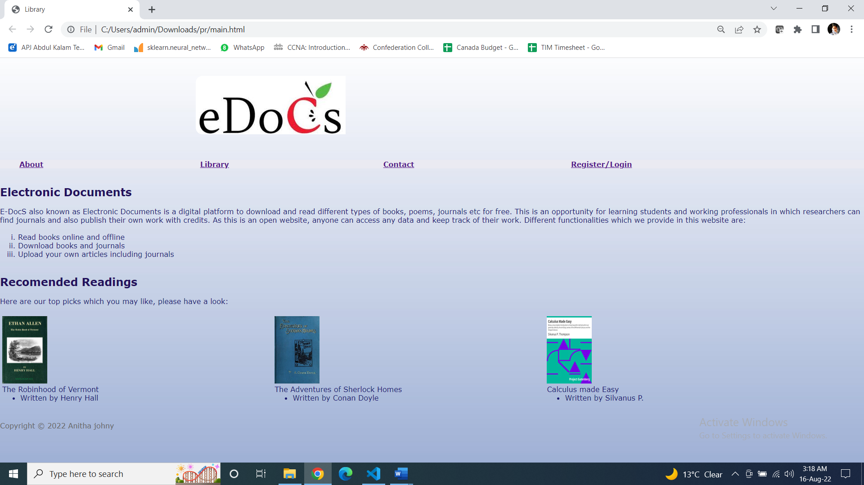

* Main.css – its having styling code for whole website
* About.html – introduction about the webpage and its contents

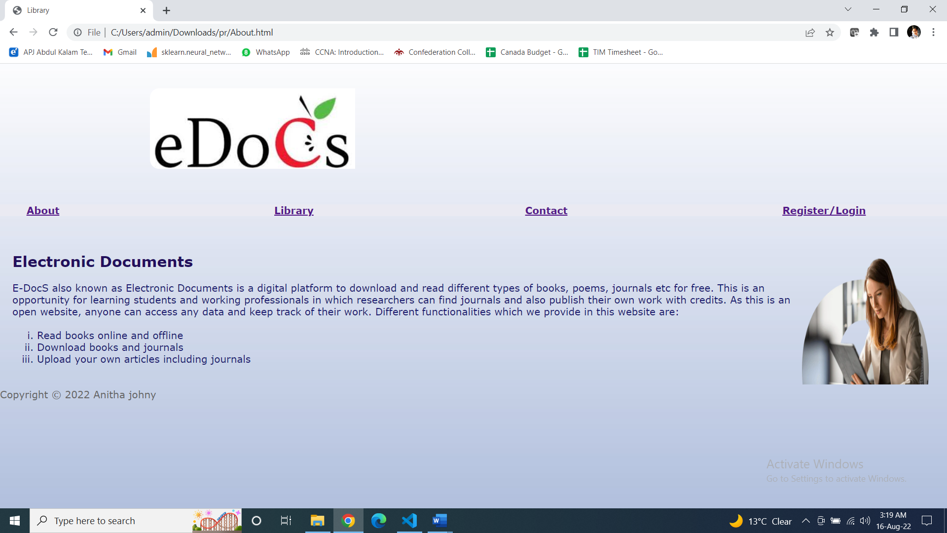

* Library.html – contains list of journals and books

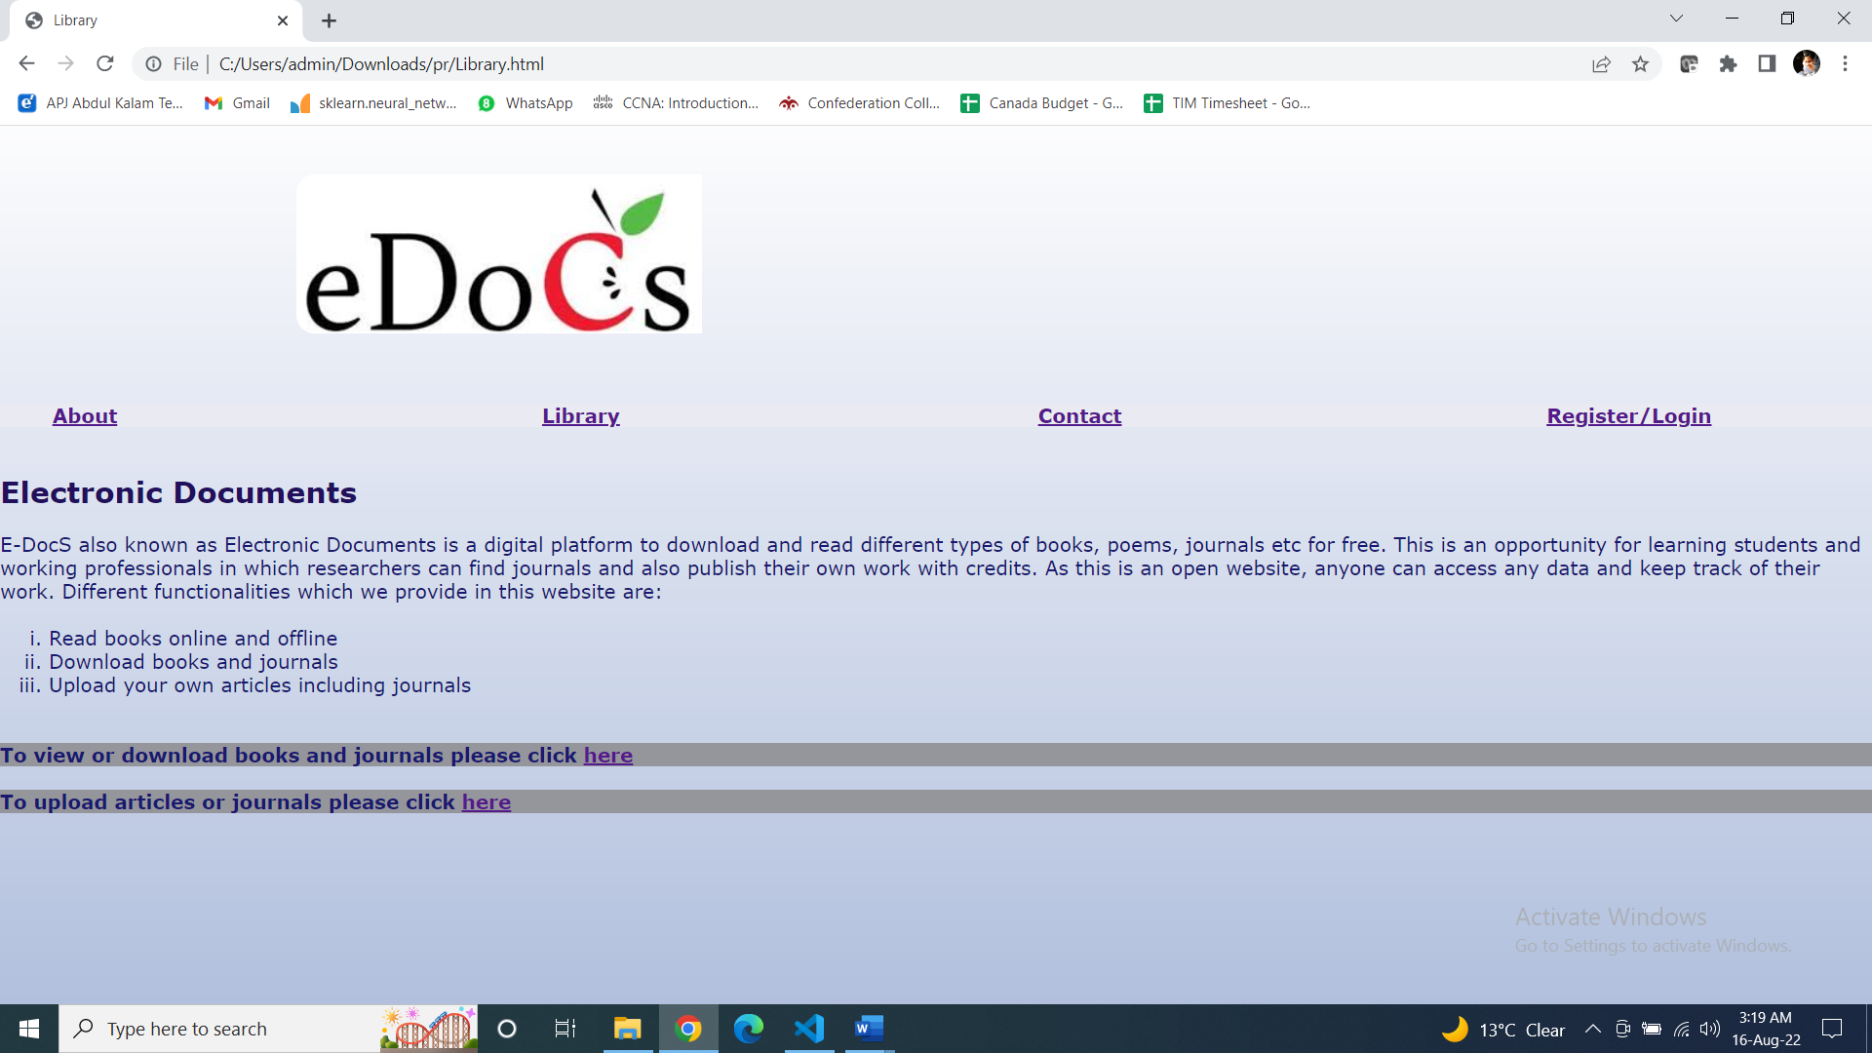

* + Download.html – User can view and download books from here

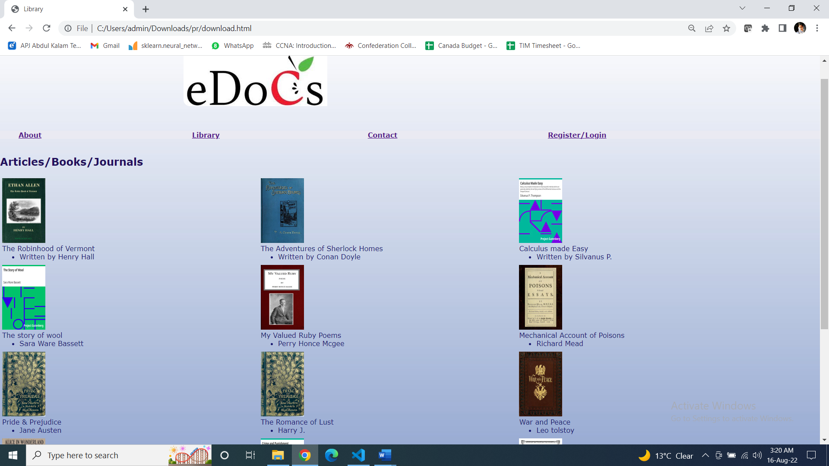

* + Upload.html – User can upload articles, books or journals here.

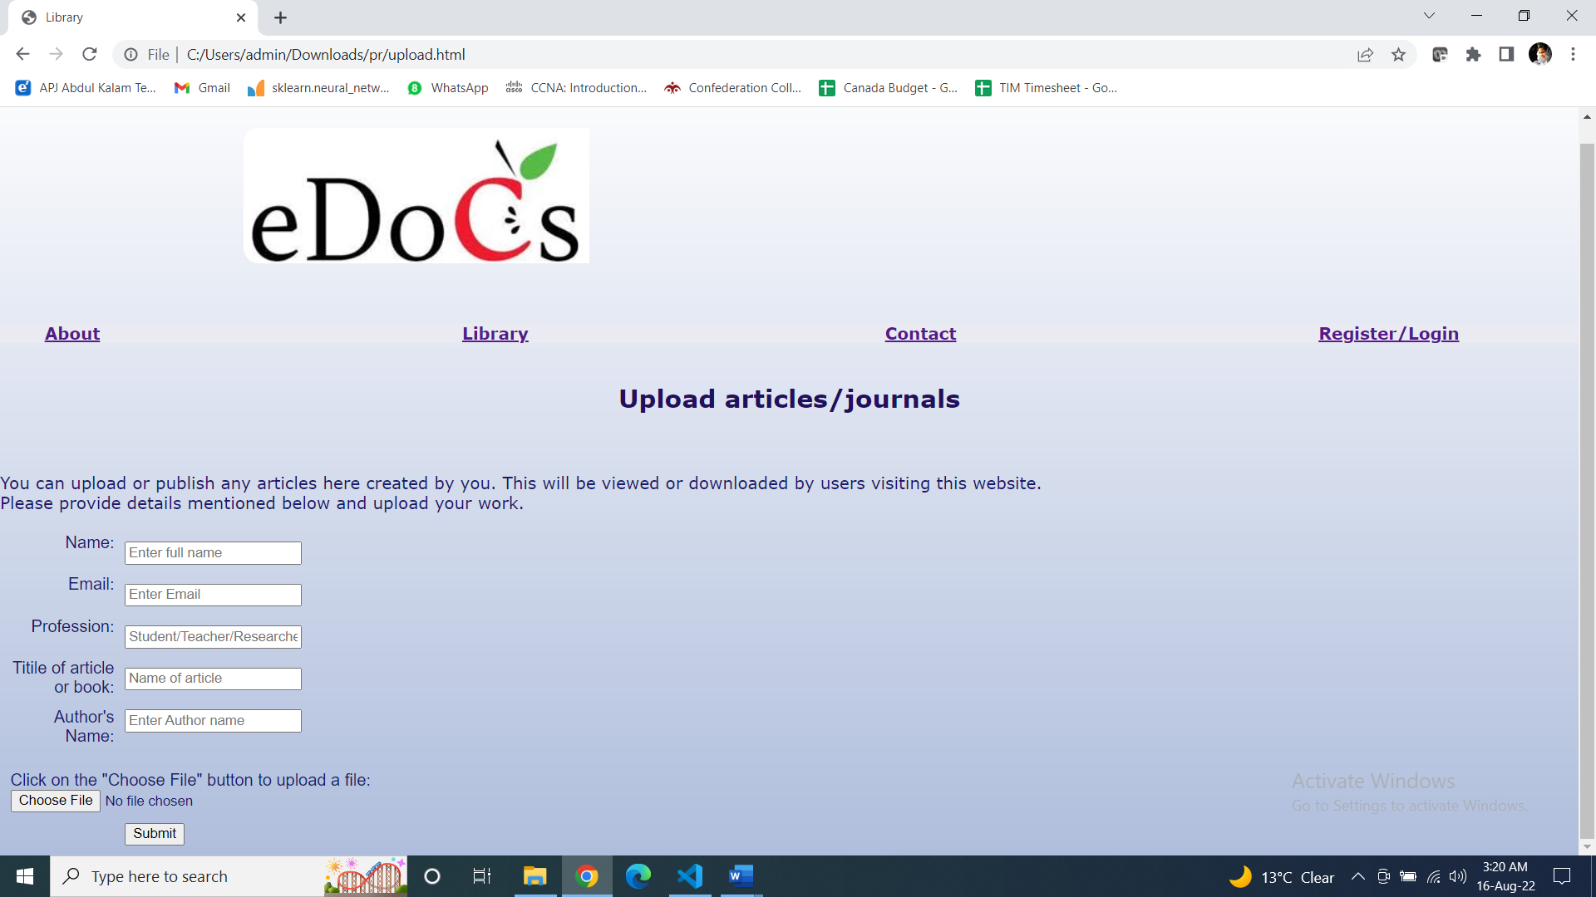

* Contact.html – contain support team contact information of this website and user can submit their feedbacks here.

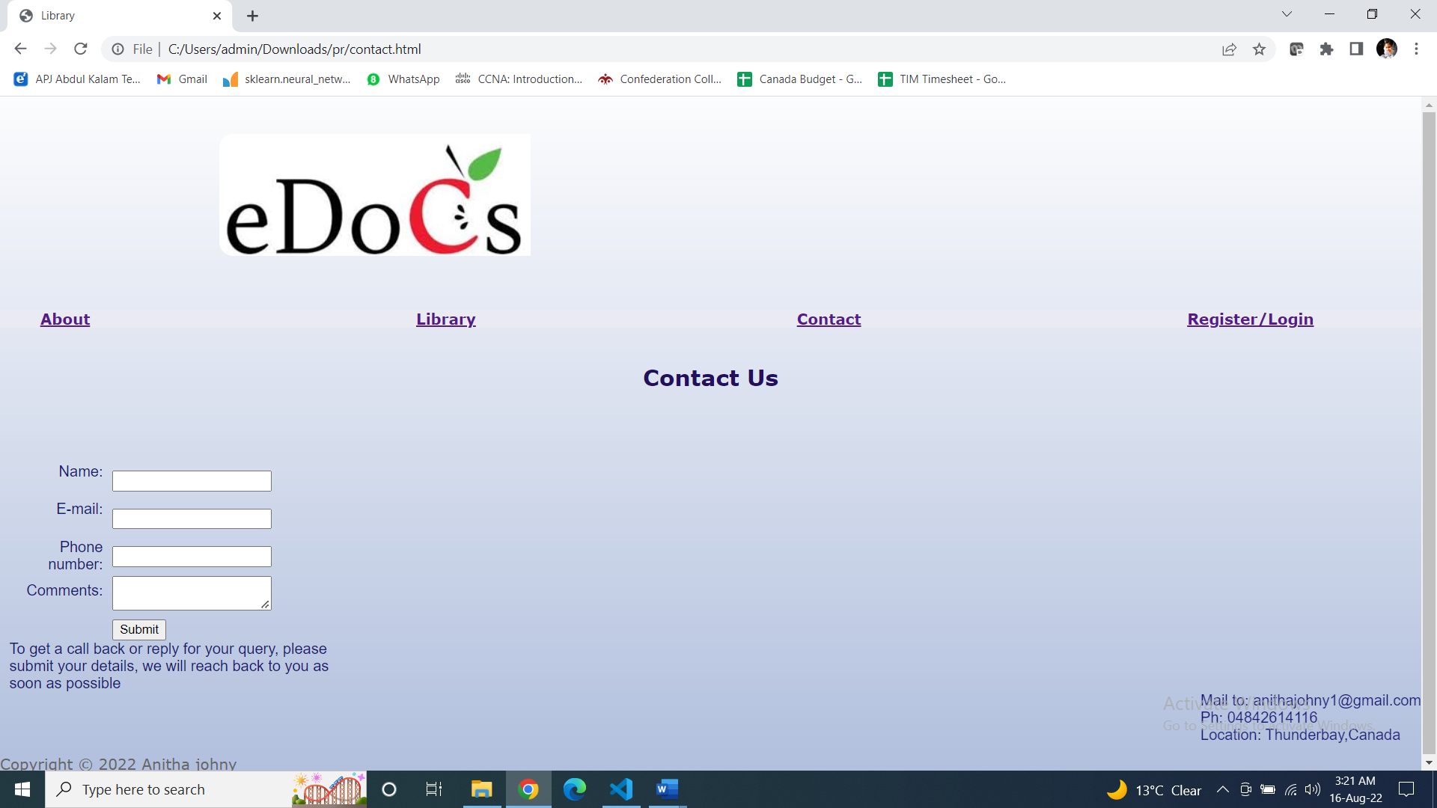

* Register.html – User can create account to track the read and unread books and also track their history

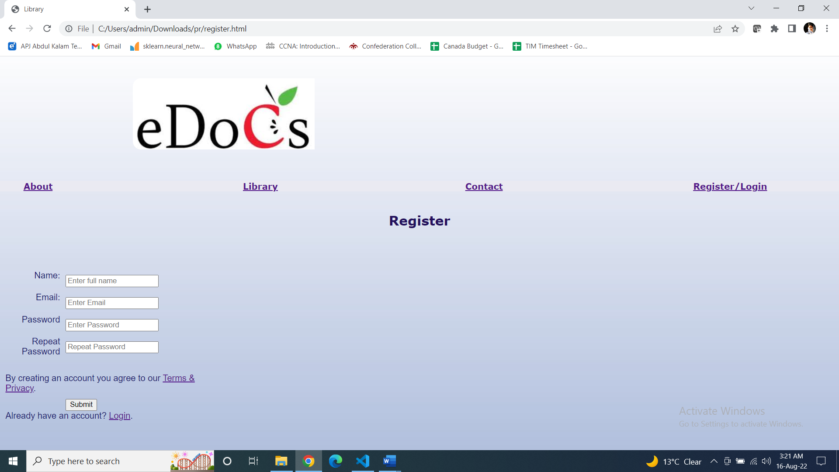

* + Login.html – User can login to their account already created

